AI Image Watermarking and Regeneration Test
This report explains a simple test performed on an AI-generated image to check how well a visible watermark survives after different image modifications. An AI-generated landscape image was first created, and then a visible watermark named “B30_SECURE_MARK” was added near the bottom area of the image. The purpose of the test was to understand whether the watermark remains after common editing actions and AI-based regeneration.
The watermarked image was tested using resizing, compression, cropping, AI regeneration, and AI editing. After resizing the image to 60%, the watermark was still visible, but it became slightly less sharp. When the image was compressed using lower JPEG quality, the watermark also remained visible, but the clarity was reduced. This shows that simple watermarks can survive basic image changes.
However, the watermark failed in stronger modification tests. When the image was cropped, the watermark was removed because the area containing it was cut out. During AI regeneration, the image was recreated with a similar scene, but the watermark was not preserved properly. This means AI tools can easily change or remove visible watermark details while generating a new version of the image.
The test shows that visible watermarking is useful for basic identification, but it is not fully secure. It can help show ownership, but it cannot strongly protect an image from intentional editing or AI regeneration. For better protection, stronger methods such as hidden watermarking, metadata verification, multi-layer watermarking, and digital fingerprinting should be used.
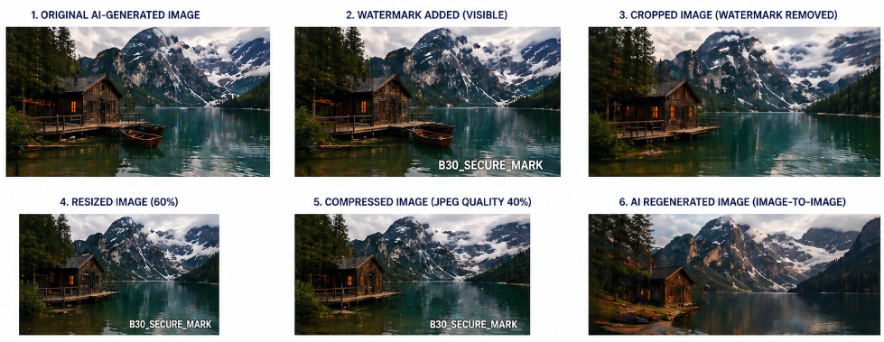
In conclusion, AI image watermarking can support image identification, but simple visible watermarks are weak against cropping and AI regeneration. Stronger watermarking techniques are needed to protect AI-generated images more reliably.

